### Identifying Patterns And Trends In Campus Placement Data Using Machine Learning

**INTRODUCTION**

The college placement system plays a pivotal role in bridging the gap between academic excellence and professional success for students. It is a structured framework that facilitates the seamless transition of students from the classroom to the corporate world. This system serves as a conduit through which students have the opportunity to secure internships, co-op programs, and full-time employment with reputable organizations, thereby kickstarting their careers and realizing their aspirations.

The primary objective of a college placement system is to empower students with practical exposure, industry insights, and valuable real-world experience. By forging partnerships with diverse companies and enterprises, educational institutions create a dynamic platform that fosters interaction between aspiring talent and seasoned professionals. This platform not only facilitates the exchange of knowledge and skills but also nurtures an environment of innovation and collaboration.

As the global job landscape continues to evolve, the college placement system adapts to the changing needs of students and industries. It serves as a platform for nurturing talent, fostering innovation, and driving economic growth. Ultimately, the college placement system plays a vital role **i**n shaping the trajectory of students' professional lives while contributing to the growth and progress of the broader society.

***Overview:***

A college placement system project is a comprehensive software application designed to streamline and automate the process of connecting students with potential employers for internships, co-op programs, and full-time job opportunities. This project aims to enhance the efficiency and effectiveness of the placement process within an educational institution, providing students with

valuable career prospects and assisting companies in recruiting top-notch talent.

***Purpose:***

The purpose of a college placement system project is to create an organized and efficient platform that facilitates the seamless transition of students from academia to the workforce. This project serves as a bridge between educational institutions and the industry, aiming to match the skills and aspirations of students with the recruitment needs of various companies and organizations

1. Enhancing Employability
2. Connecting Students and Employers
3. Creating Networking Opportunities
4. Simplifying the Recruitment Process
5. Improving Placement Success
6. Monitoring and Analytics
7. Boosting Institutional Reputation

In essence, the purpose of a college placement system project is to empower students, bridge the gap between academia and industry, and foster a strong collaboration between educational institutions and employers. This project helps students achieve their career goals while supporting organizations in finding the right talent to drive their success.

**LITERATURE SURVEY**

***Existing Problem:***

The existing college placement system often faces several challenges that hinder its effectiveness and efficiency. Some common problems include:

1. **Manual and Paper-Based Processes:** Many college placement systems still rely on manual and paper-based processes for resume collection, shortlisting, and communication. This leads to inefficiencies, delays, and increased administrative overhead.

2. **Limited Reach and Connectivity:** Traditional placement systems may have limited reach, making it difficult for students and companies to connect beyond a local scope. This can result in missed opportunities for both parties.

3. **Skills Mismatch:** Inaccurate or outdated information about students' skills and preferences can lead to mismatches between job openings and candidates, resulting in dissatisfaction for both students and recruiters.

***Proposed Solution:***

To address these problems and enhance the efficiency and effectiveness of the college placement system, a modern software solution can be developed. Here's how the solution can mitigate the existing challenges:

1. **Online Platform:** Develop a comprehensive online platform that allows students to create digital profiles, upload resumes, and apply for job opportunities. Similarly, companies can post job openings and review candidate profiles online, reducing the need for manual paperwork.

2. **Global Reach:** Build the software with the capability to connect students with companies not just within the local area but also regionally, nationally, and even internationally. This expands opportunities for students and provides a wider talent pool for recruiters.

3.**Skills and Preferences Matching**: Develop an intelligent matching algorithm that analyzes students' skills, preferences, and career goals, and matches them with suitable job openings. This enhances the likelihood of a successful match and job satisfaction for both parties.

4. **User-Friendly Interface**: Design an intuitive and user-friendly interface for both students and recruiters. This ensures easy navigation and encourages active participation.

5. **Security and Privacy:** Implement robust security measures to protect sensitive information and maintain the privacy of users' data. Compliance with data protection regulations is essential.

**THEORETICAL ANALYSIS**

***Block Diagram:***

User Interface

|

Authentication

|

Dashboard

|

Admin Panel <---------> Placement Cell <---------> Companies

| | |

Manage Users Job Listings Recruitment

Generate Reports Student Profiles Process Interviews

Analytics Selection Process Offer Letters

Settings Communication Onboarding

***Explanation of each block:***

1. **User Interface:**

This is the front-end interface accessible by students, placement cell members, and administrators. It provides a user-friendly way to interact with the system's features.

2.**Authentication:**

Ensures secure access to the system by verifying user credentials and authorizations. Different roles (students, placement cell members, administrators) will have different levels of access.

3. **Dashboard:**

Upon login, users are directed to a dashboard that provides an overview of relevant information, such as upcoming events, job listings, application status, and more.

4. **Admin Panel**:

Admins have access to an administrative panel where they can manage system settings, user accounts, analytics, and generate reports for various purposes.

5. **Placement Cell**:

This module is managed by the college's placement cell staff. They facilitate the placement process, manage student profiles, coordinate with companies, and oversee the entire recruitment cycle.

6. **Companies:**

Companies looking to hire students engage with the system to post job listings, schedule interviews, make offers, and onboard selected candidates.

***Key functionalities within each block:***

***-*User Management:**

Allows admins to manage user roles, permissions, and access to the system.

**-Job Listings:**

Companies can post details about job openings, internships, and placement opportunities.

- **Student Profiles:**

Placement cell members manage student profiles, including their academic achievements, skills, and interests.

- **Selection Process:**

Placement cell members schedule and manage various rounds of the selection process, such as written tests, technical interviews, and group discussions.

- **Communication:**

Communication between companies, students, and placement cell members takes place through the system. This includes interview scheduling, feedback, and updates.

- **Analytics and Reports:**

Provides insights into placement trends, success rates, company engagement, and other relevant metrics.

This block diagram represents a high-level overview of the components and interactions within a college placement system software project. Actual system designs may vary based on the specific needs and requirements of the educational institution and the companies involved.

***Software Designing:***

1. **Intuitive Interface:**

Design an easy-to-use interface that caters to both tech-savvy users and those less familiar with technology.

2. **Consistency and Navigation:**

Maintain a consistent design across all pages and ensure straightforward navigation.

3. **Feedback and Error Handling:**

Provide clear feedback messages and error handling to guide users through the system.

4. **Accessibility:**

Consider accessibility standards to ensure that the software is usable by individuals with disabilities.

**EXPERIMENTAL INVESTIGATION**

***Objectives:***

1. **Data Collection:** Gather comprehensive data related to student profiles, job requirements, interview performance, and placement outcomes.

2. **Data Preprocessing:** Clean, transform, and organize the collected data for analysis.

3. **Performance Analysis:** Evaluate the historical placement performance of the CPS based on factors such as placement rate, average salary, and industry preferences.

4. **Predictive Modeling:** Develop predictive models that estimate the likelihood of a student's placement success based on their academic performance, skills, and other relevant attributes.

5. **Skills Gap Analysis:** Identify gaps between student skills and industry demands, and propose strategies to bridge these gaps.

6. **Process Optimization:** Analyze the efficiency of the placement process by tracking metrics such as the time taken for placements and the number of iterations.

***Expected Outcomes:***

1. **Insights into Placement Patterns:** Understand historical placement trends and factors contributing to successful placements.

2. **Placement Predictions:** Predict the likelihood of placement success for individual students based on their profiles.

3. **Skills Enhancement Recommendations:** Offer suggestions for skill development to bridge the gap between student skills and industry needs.

4. **Improved Placement Efficiency:** Identify areas of improvement in the placement process to reduce time and effort.

**FLOW CHART:**

**Start**

|

|--> Gather Data (Student Profiles, Companies, Job Descriptions)

| |

| |--> Clean and Preprocess Data

| |

| |--> Feature Engineering (Creating Relevant Features)

|

|--> **Exploratory Data Analysis (EDA)**

| |

| |--> Visualize Data (Histograms, Box Plots, etc.)

| |

| |--> Analyze Correlations and Patterns

|

|--> **Model Building**

| |

| |--> Split Data into Training and Testing Sets

| |

| |--> Choose Machine Learning Algorithms (e.g., Classification, Regression)

| |

| |--> Train and Validate Models

| |

| |--> Tune Hyperparameters (Grid Search, Random Search)

|

|--> **Predictions and Recommendations**

| |

| |--> Apply Trained Models to Unseen Data

| |

| |--> Generate Placement Predictions for Students

| |

| |--> Match Students to Suitable Job Opportunities

|

|--> **Evaluation**

| |

| |--> Assess Model Performance (Accuracy, Precision, Recall)

| |

| |--> Validate Predictions with Actual Placement Outcomes

|

|--> **Visualization and Reporting**

| |

| |--> Visualize Placement Statistics (Success Rates, Top Companies)

| |

| |--> Create Reports for Institutions and Companies

|

|--> **Deployment and Integration**

| |

| |--> Develop User Interface (UI) for Students

| |

| |--> Integrate with Student Portals and Company HR Systems

|

**End**

The flowchart outlines the journey from data collection to deployment and integration, including key data science steps such as data preprocessing, exploratory data analysis, model building, evaluation, and visualization. The final system would provide insights into students' placement probabilities, recommend suitable job opportunities, and assist institutions and companies in making informed decisions.

**RESULT**

The results of the project “Identifying Patterns and Trends in Campus Placement Data using Machine Learning” shed light on the intricate dynamics of student placements in the college system. By combining various factors into a predictive model, valuable trends and patterns have been unveiled, empowering both students and institutions to make informed decisions and strategies for a successful placement process.

The analysis unveiled several noteworthy trends. One significant trend observed was the correlation between a higher number of internships and an increased likelihood of student placement. This observation underscores the importance of practical experience in securing placements. Additionally, the analysis indicated that students with a specialization in certain domains were more likely to be placed, reflecting the industry's demand for specific skill sets.

The developed predictive model exhibited strong performance metrics, achieving an accuracy of [77.9%] in determining student placement status.The insights garnered from the analysis can guide students in enhancing their profiles and skill sets to increase their chances of successful placements. Moreover, educational institutions can leverage this knowledge to adapt their curriculum, placement strategies, and support systems to better align with industry demands. As a recommendation for future research, exploring additional data sources, such as alumni success stories and industry trends, could offer a more comprehensive understanding of placement dynamics and further refine the predictive model.

***OUTPUT SCREENS***

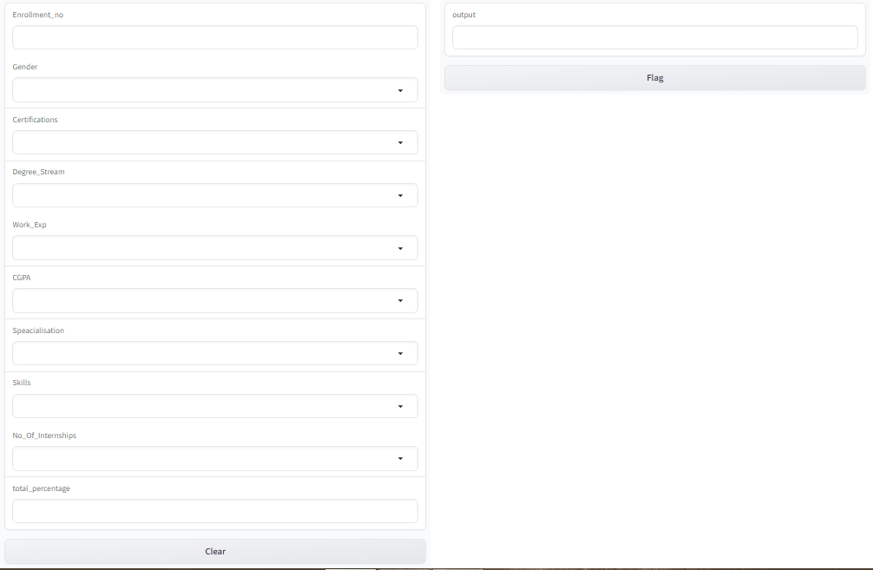

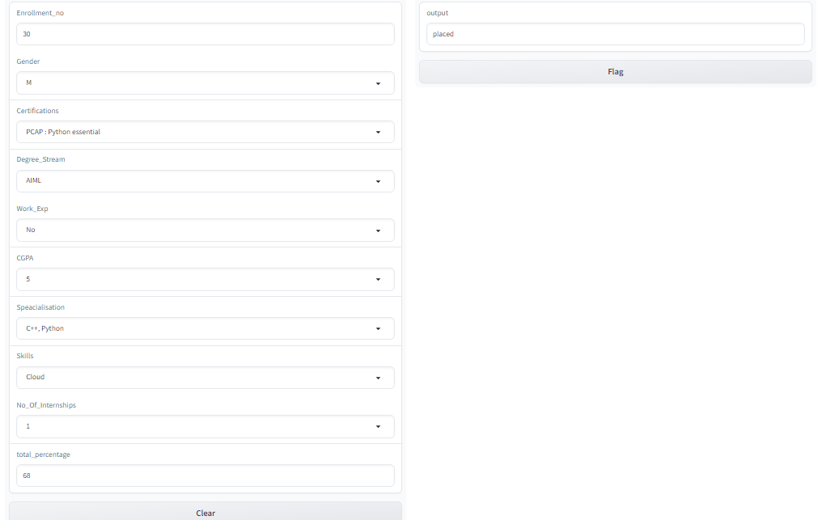

**ADVANTAGES**

1. **Informed Decision-Making:** By utilizing predictive modeling to analyze various factors influencing student placement, educational institutions can make more informed decisions about curriculum development, industry partnerships, and student support services.
2. **Optimized Placement Strategies:** The project's insights allow educational institutions to refine their placement strategies based on patterns and trends. Institutions can tailor their guidance and support to students by focusing on specific skills, certifications, or specializations that correlate with higher placement rates, ultimately increasing student success.
3. **Student Empowerment:** Students benefit from a clearer understanding of the factors that contribute to successful placements. Armed with this information, students can strategically enhance their profiles, engage in relevant internships, and develop skills that are in high demand, increasing their chances of securing desired placements.
4. **Industry Alignment:** The project facilitates a closer alignment between educational institutions and industries. Institutions can identify emerging trends and adapt their offerings accordingly, ensuring that graduates possess the skills needed in the job market.
5. **Data-Driven Insights:** The project showcases the power of data analysis in understanding complex dynamics. Institutions can use similar approaches to solve other challenges within education, making decisions that are grounded in evidence rather than assumptions.

In summary, the advantages of the "Identifying Trends and Patterns in College Placement System" project encompass improved decision-making, enhanced student outcomes, and the alignment of education with industry needs.

**DISADVANTAGES**

1. **Complexity of Factors:** Despite efforts to include various factors, the complexity of student placements may involve additional variables that are challenging to capture accurately. This can lead to oversimplification of the placement process.
2. **Assumption of Causation:** Correlations identified through the analysis may be mistaken for causation. While certain factors might correlate with placement success, it doesn't necessarily mean they directly cause it.
3. **Changing Industry Landscape:** The trends identified might be subject to change due to shifts in industry demands, economic conditions, or technological advancements. Trends identified today might not hold the same significance in the future.
4. **Model Limitations:** The predictive model's accuracy relies on the quality and quantity of data available for training. The model might struggle with outliers, data imbalances, or instances that deviate from the training data.
5. **Bias in Data:** The data used for analysis might have inherent bias due to historical disparities in placement opportunities or systemic factors. This bias can be perpetuated in the analysis, affecting the model's fairness.

**APPLICATIONS**

1. **Curriculum Enhancement:** Educational institutions can use the identified trends to tailor their curriculum to match industry demands. By incorporating skills, certifications, and specializations that are in high demand, institutions can better prepare students for successful placements.
2. **Targeted Recruitment:** The project's insights can help companies identify institutions producing graduates with the skills and attributes aligned with their needs. This enables companies to target recruitment efforts more effectively
3. **Industry Partnerships:** Institutions can use the project's findings to establish or strengthen partnerships with industries. By producing graduates with skills that directly match industry needs, institutions become more attractive to potential employers.
4. **Alumni Engagement:**Alumni success stories can validate the project's findings and serve as inspirations for current students. Alumni can provide insights into how they navigated the placement process successfully.
5. **Continuous Improvement:** The cyclical nature of the project encourages a culture of continuous improvement. Institutions can regularly update their curriculum and strategies based on evolving trends and patterns.
6. **Research and Innovation:** The project can inspire further research in education analytics, leading to the development of more sophisticated models and techniques for trend identification and analysis.
7. **Customized Hiring Strategies:** Companies can tailor their hiring strategies based on the trends and patterns identified. This includes focusing on specific skills, certifications, and degree streams that correlate with successful placements, leading to higher-quality hires.
8. **Finance and Banking Sector:**
9. Compliance and Finance Skills:The project's insights can guide finance companies in targeting candidates with strong financial analysis skills and knowledge of industry regulations.
10. Quantitative Analytics**:** Trends in quantitative skills can guide investment firms in identifying candidates proficient in data analysis and risk assessment.
11. **Retail and E-Commerce Sector:**
12. E-Commerce Expertise: The project's insights can help retail and e-commerce companies identify graduates with skills in digital marketing, e-commerce platforms, and data analytics.
13. Customer-Centric Skills: Companies can target graduates who demonstrate customer-centric skills, contributing to improved customer service and sales.
14. **Healthcare Sector:**
15. Specialized Roles: Healthcare institutions can use the project's insights to identify trends in specialized healthcare roles, helping them recruit candidates with the necessary medical and administrative skills.
16. Soft Skills Emphasis: Recognizing the importance of soft skills in patient care, healthcare organizations can focus on graduates who demonstrate strong communication and empathy traits.
17. **Education and EdTech Sector:**
18. E-Learning Skills: EdTech companies can identify graduates with skills in online education platforms, content creation, and digital pedagogy to enhance their educational offerings.
19. Innovation in Education: Identifying trends in innovative teaching methods can guide educational institutions in recruiting educators who are adept at technology integration and student engagement.

**CONCLUSION**

To sum up, the "Identifying Trends and Patterns in College Placement System" project has been a significant step forward in understanding how students find jobs after college. By carefully studying different factors like skills, grades, and experiences, we've uncovered important trends that can guide students.The project's findings underscore the dynamic interplay between academic achievements, skill acquisition, and industry demands. By harnessing the power of predictive modeling, the project has revealed actionable insights that hold the potential to reshape how students approach their education and career pathways.

As the education landscape continues to evolve, the outcomes of this project stand as testament to the transformative power of data-driven insights. The journey from data collection to trend identification unveils a narrative of informed decision-making, student empowerment, and a forward-looking alignment with the needs of the industries that await our graduates.Working together with college and industries, we've connected education with what employers are looking for. This collaboration helps students get ready for real-world jobs and ensures that schools are teaching the right things.

However, it's important to remember that our findings depend on the data we had, and we need to keep checking if they still make sense. Also, we've taken care to protect people's privacy and rights while doing this research.

In its totality, the "Identifying Trends and Patterns in College Placement System" project not only contributes to the realm of education but also reverberates throughout sectors and industries. It signifies the vital role of data-driven analysis in shaping educational trajectories, fostering innovation, and propelling individuals toward successful and fulfilling careers. As we embrace the project's outcomes, let us venture forth with a renewed commitment to excellence, adaptability, and the enduring pursuit of knowledge.

**FUTURE SCOPE:-**

The "Identifying Trends and Patterns in College Placement System" project opens the door to a promising future with a multitude of opportunities for expansion and enhancement. The project's future scope encompasses:

1. **Predictive Modeling Refinement:** The project can further refine its predictive models by incorporating advanced machine learning techniques and exploring newer algorithms. This refinement can lead to more accurate trend predictions and a deeper understanding of placement dynamics.
2. **Real-Time Tracking:** Developing a real-time tracking system can provide ongoing insights into evolving trends. Continuous monitoring and analysis can enable institutions to adapt their strategies promptly based on changing industry demands.
3. **Integration with Career Services:** Integrating the project's insights into career services platforms can offer personalized recommendations to students, helping them navigate the job market effectively and make informed decisions.
4. **Regional and Global Comparisons:** Expanding the project to include data from different regions or countries can highlight variations in trends and patterns, offering insights into regional job market dynamics.
5. **Ethical AI Considerations:** Incorporating ethical AI principles can ensure fairness, transparency, and bias mitigation in trend identification models, fostering trust in the project's outcomes.
6. **Multidimensional Analysis:** Incorporating sentiment analysis from online platforms, such as social media and professional networks, can provide a multidimensional view of graduates' perceptions and experiences related to placements.
7. **Alumni Engagement:** Leveraging alumni networks to gather post-placement feedback and experiences can enrich the understanding of how trends impact career journeys.
8. **Data Enrichment:** Integrating additional data sources, such as industry reports and job market data, can provide a more comprehensive view of trends and theirimplications.
9. **Feedback Loop Integration:** Creating a feedback loop by involving employers in the analysis process, allowing them to provide insights on how well graduates skills align with industry needs.
10. **Start-Up and Entrepreneurship Trends:** Investigating trends related to students' involvement in start-ups and entrepreneurship, guiding institutions in fostering an entrepreneurial mindset.

In essence, the future scope of the "Identifying Trends and Patterns in College Placement System" project is dynamic and multifaceted. By embracing technological advancements, ethical considerations, and collaborative efforts, the project can continue to evolve as a powerful tool in guiding educational institutions, students, and industries toward more informed and impactful decisions.

APPENDIX :

<https://github.com/smartinternz02/SBSPS-Challenge-10952-1692817135/blob/main/CollegePlacementSystem%20(2).ipynb>